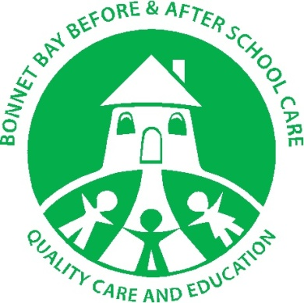
Bonnet Bay Before & After School Care

Contact Details:
Address: 34R Tudor Rd, Bonnet Bay 2226
Ph: 9528 8797
Email: bbbascbasc@yahoo.com.au
Website: www.shirechildcarecentres.com.au

About us
Bonnet Bay Before and After School Care Service educates and cares for children K-6 from Bonnet Bay Public School and St Josephs Catholic School. The service is located in the grounds of Bonnet Bay Public school in a newly built demountable classroom, landscaped in tune with the natural bush setting of the area. There is an expansive outdoor grassed area with play equipment. Your child can use the wide variety of games and sporting equipment and participate in activities such as soccer, Frisbee and tennis.

Operating Hours
Monday – Friday
Morning: 7am – 9am
Afternoon: 3pm – 6pm

Before & After School Care Program
Our qualified educators incorporate the “My Time Our Place Framework”, encouraging children to choose between exploring, experimenting, being active or finding a quiet area to read a book or just be. Our fun filled program includes, craft, computer games, group games, outside games and sport. We also take learning very seriously and if you choose to have your child do their homework at our centre we will make sure they are getting the best support. We have at least one dedicated educator for this, ensuring that encouragement is given and questions and queries are answered.

Meals
Breakfast: Our Centres understand the importance of starting the day with a healthy meal. For breakfast we offer a choice of Weet-Bix, Rice Bubbles, milk, toast, butter, jam and Vegemite. We also welcome children to bring in any other healthy breakfast items of their choice.

Afternoon tea: After School Care provides a variety of nutritious afternoon snacks intended to give students a boost of energy after a long day of learning, however not spoil their evening meal. Our menu includes fresh fruit and vegetable platters, dips, cut sandwiches, cheese and biscuits and soup.

